REPORT

CUSTOMER'S REF NO:
ALS THAILAND REF NO.: | ATT/ELP/14/3496-H
ALS SINGAPORE REF NO.: | ATS/ELT/1315/14
DATE: | 22 January 2015
COMPANY: | SEI Interconnect Products (Thailand)Ltd.
 | 700/128 Moo 5 Bangna-Trad Road, T. Klong Tam Roo
 | A. Muang, Chonburi 20000
DATE SAMPLE RECEIVED: | 26 December 2014
DATE ANALYZED: | 09 January 2015
DATE TEST COMPLETED: | 20 January 2015

SAMPLE DESCRIPTION: | One lot of sample was received with references:
Description: RQ14-1737 Tahoe_XL APFA ww# 27
After Crest# 11 cell# 8
MinAik/EngTek/LSI+SUMI/Rencol/ISC
PN. 2053-208501-F21 PR: 18kn00011878
 | Model: Tahoe_XL APFA
 | Surface Area: APFA = 83.60 cm2 AFA =73.80 cm2

METHOD:
Particle Analysis by SEM EDX | Taped Area For Drive Parts | No. of Times Taped | Surface Area Analysed (cm2) | Particle Ranges
Procedure No:  2092-701412 Rev. AE | Arm | 3 | 0.02090 | 0.5um - 5.0um
Procedure No:  2092-701412 Rev. AE | Pivot | 8 | 0.02090 | 0.5um - 5.0um
Procedure No:  2092-701412 Rev. AE | Swage | 4 | 0.02090 | 0.5um - 5.0um

RESULTS:
The Specification is based on WD's specification Doc No 96-004575 Rev.AX for APFA Single Platter / (CP/ECD) (3.5" Enterprise & 3.5" Desktop)
 | Total Hard Particles/cm2 | Total MgSiO Particles/cm2 | Total Steel Particles/cm2 | Total Magnetic Particles/cm2
Result on Arm | 0 | 0 | 48 | 0
Result on Pivot | 48 | 0 | 707 | 0
Result on Swage | 72 | 0 | 216 | 0
Average result | 40 | 0 | 324 | 0
Specification | <400 | <100 | <800 | 0
PASS / FAIL | PASS | PASS | PASS | PASS

Total hard particles/cm2 = total no. of hard particles/(no. of times taped x surface area analysed)
Note: This report was performed test by ALS Singapore.

ALS THAILAND REF NO.: |  | ATT/ELP/14/3496-H
ALS SINGAPORE REF NO.: |  | ATS/ELT/1315/14
DATE: |  | 22 January 2015
COMPANY: |  | SEI Interconnect Products (Thailand)Ltd.
Stage Mimic of Arm | Stage Mimic of Pivot |  | Stage Mimic of Swage
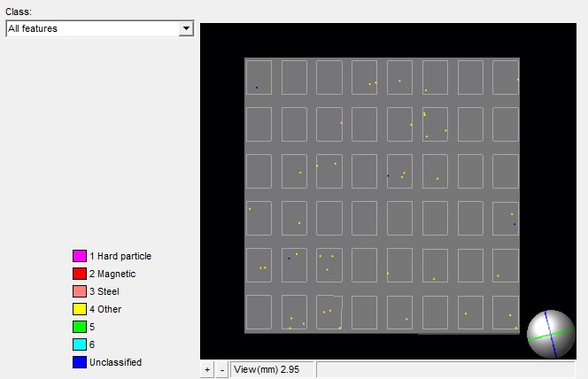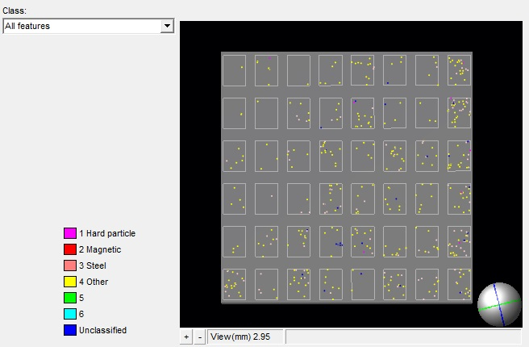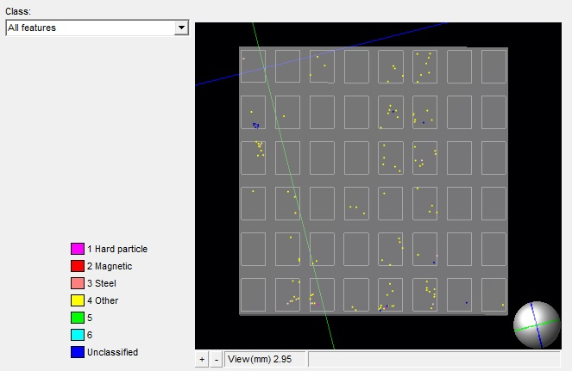
Please refer to attachment for details of results
Analysis Table on Arm
Elemental Composition | Count | Particle/cm2 | Remarks
Hard Particles
Al-O | 0 | 0
Al-Si-O | 0 | 0
Si-O | 0 | 0
Si-C | 0 | 0
Al-Cu-O | 0 | 0
Al-Mg-O | 0 | 0
Al-Si-Cu-O | 0 | 0
Al-Si-Fe-O | 0 | 0
Al-Si-Mg-O | 0 | 0
Al-Ti-O | 0 | 0
Ti-O | 0 | 0
Ti-C | 0 | 0
Ti-B | 0 | 0
Ti-N | 0 | 0
W-O | 0 | 0
W-C | 0 | 0
Zr-O | 0 | 0
Zr-C | 0 | 0
Pb-Zr-Ti-O | 0 | 0
Subtotal - Hard Particles Only | 0 | 0
Magnetic Particle
Ce-Co | 0 | 0
Fe-Nd | 0 | 0
Fe-Sm | 0 | 0
Fe-Sr | 0 | 0
Nd-Pr | 0 | 0
Ni-Co | 0 | 0
Sm-Co | 0 | 0
Subtotal - Magnetic Particles Only | 0 | 0
Subtotal- Hard Particles including Magnetic Partilces | 0 | 0

ALS THAILAND REF NO.: | ATT/ELP/14/3496-H
ALS SINGAPORE REF NO.: | ATS/ELT/1315/14
DATE: | 22 January 2015
COMPANY: | SEI Interconnect Products (Thailand)Ltd.
Analysis Table on Arm
Elemental Composition |  | Count | Particle/cm2 | Remarks
Steel Particle
SS 300- Fe-Cr-Ni |  | 0 | 0
SS 300- Fe-Cr-Ni-Mn |  | 2 | 32
SS 300- Fe-Cr-Ni-Si |  | 0 | 0
SS 400- Fe-Cr |  | 1 | 16
SS 400- Fe-Cr-Mn |  | 0 | 0
Other Steel - Fe |  | 0 | 0
Other Steel - Fe-Mn |  | 0 | 0
Other Steel - Fe-Ni |  | 0 | 0
Other Steel - Fe-O |  | 0 | 0
Subtotal - Steel Particle Only |  | 3 | 48
Other Particle
No Element |  | 0 | 0
Ni |  | 0 | 0
Ni-P |  | 0 | 0
Sn base |  | 23 | 367
Other |  | 7 | 112
Al |  | 0 | 0
Al-Mg |  | 0 | 0
Al-Ti |  | 1 | 16
Al-Si (1) |  | 0 | 0
Al-Si (2) |  | 0 | 0
Si |  | 0 | 0
Al-Cu |  | 0 | 0
Al-Si-Cu |  | 0 | 0
Al-Si-Fe |  | 0 | 0
Al-Si-Mg |  | 1 | 16
Mg-Si-O-Al |  | 0 | 0
Mg-Si-O |  | 0 | 0
Ti |  | 0 | 0
Nd |  | 0 | 0
S-Cr-Mn |  | 0 | 0
Zn base |  | 0 | 0
Ca base |  | 1 | 16
Ni base |  | 0 | 0
Cr base |  | 0 | 0
Zr base |  | 0 | 0
Cl base |  | 0 | 0
Na-Cl |  | 0 | 0
Cu |  | 0 | 0
Cu-Au |  | 0 | 0
Ag-S |  | 0 | 0
ALS THAILAND REF NO.: | ATT/ELP/14/3496-H
ALS SINGAPORE REF NO.: | ATS/ELT/1315/14
DATE: | 22 January 2015
COMPANY: | SEI Interconnect Products (Thailand)Ltd.

Elemental Composition | Count | Particle/cm2 | Remarks
Au-Ni | 0 | 0
Ag | 0 | 0
Au | 1 | 16
Cu-Au-Ni | 0 | 0
Cu-Zn | 0 | 0
Cu-Zn-Ni | 0 | 0
Cu-Zn-Au-Ni | 0 | 0
Zn-O | 0 | 0
Pb | 0 | 0
Fe-Cu | 0 | 0
Cr-Mn | 0 | 0
Al-Si Base | 2 | 32
F-O | 0 | 0
Cu-S-Al-O Base | 1 | 16
Ti-O/Al-Si-Fe | 1 | 16
Cr-Rich (Cr Base + Cr-Mn) | 0 | 0
Subtotal - Other Particle Only | 38 | 607
Grand Total of Particles | 41 | 655

Analysis Table on Pivot
Elemental Composition |  | Count | Particle/cm2 | Remarks
Hard Particles
Al-O |  | 3 | 18
Al-Si-O |  | 1 | 6
Si-O |  | 1 | 6
Si-C |  | 0 | 0
Al-Cu-O |  | 0 | 0
Al-Mg-O |  | 0 | 0
Al-Si-Cu-O |  | 0 | 0
Al-Si-Fe-O |  | 0 | 0
Al-Si-Mg-O |  | 0 | 0
Al-Ti-O |  | 1 | 6
Ti-O |  | 1 | 6
Ti-C |  | 1 | 6
Ti-B |  | 0 | 0
Ti-N |  | 0 | 0
W-O |  | 0 | 0
W-C |  | 0 | 0
Zr-O |  | 0 | 0
Zr-C |  | 0 | 0
Pb-Zr-Ti-O |  | 0 | 0
Subtotal - Hard Particles Only |  | 8 | 48
ALS THAILAND REF NO.: | ATT/ELP/14/3496-H
ALS SINGAPORE REF NO.: | ATS/ELT/1315/14
DATE: | 22 January 2015
COMPANY: | SEI Interconnect Products (Thailand)Ltd.

Magnetic Particle
Ce-Co | 0 | 0
Fe-Nd | 0 | 0
Fe-Sm | 0 | 0
Fe-Sr | 0 | 0
Nd-Pr | 0 | 0
Ni-Co | 0 | 0
Sm-Co | 0 | 0
Subtotal - Magnetic Particles Only | 0 | 0
Subtotal- Hard Particles including Magnetic Partilces | 8 | 48

Analysis Table on Pivot
Elemental Composition | Count | Particle/cm2 | Remarks
Steel Particle
SS 300- Fe-Cr-Ni | 73 | 437
SS 300- Fe-Cr-Ni-Mn | 9 | 54
SS 300- Fe-Cr-Ni-Si | 10 | 60
SS 400- Fe-Cr | 21 | 126
SS 400- Fe-Cr-Mn | 0 | 0
Other Steel - Fe | 0 | 0
Other Steel - Fe-Mn | 0 | 0
Other Steel - Fe-Ni | 0 | 0
Other Steel - Fe-O | 5 | 30
Subtotal - Steel Particle Only | 118 | 707
Other Particle
No Element | 0 | 0
Ni | 1 | 6
Ni-P | 0 | 0
Sn base | 119 | 712
Other | 71 | 425
Al | 27 | 161
Al-Mg | 5 | 30
Al-Ti | 0 | 0
Al-Si (1) | 2 | 12
Al-Si (2) | 29 | 173
Si | 0 | 0
Al-Cu | 0 | 0
Al-Si-Cu | 3 | 18
Al-Si-Fe | 1 | 6
Al-Si-Mg | 30 | 179
Mg-Si-O-Al | 0 | 0
Mg-Si-O | 0 | 0

ALS THAILAND REF NO.: | ATT/ELP/14/3496-H
ALS SINGAPORE REF NO.: | ATS/ELT/1315/14
DATE: | 22 January 2015
COMPANY: | SEI Interconnect Products (Thailand)Ltd.

Elemental Composition | Count | Particle/cm2 | Remarks
Ti | 0 | 0
Nd | 0 | 0
S-Cr-Mn | 0 | 0
Zn base | 3 | 18
Ca base | 5 | 30
Ni base | 1 | 6
Cr base | 0 | 0
Zr base | 0 | 0
Cl base | 2 | 12
Na-Cl | 0 | 0
Cu | 1 | 6
Cu-Au | 0 | 0
Ag-S | 0 | 0
Au-Ni | 1 | 6
Ag | 0 | 0
Au | 2 | 12
Cu-Au-Ni | 0 | 0
Cu-Zn | 18 | 108
Cu-Zn-Ni | 0 | 0
Cu-Zn-Au-Ni | 0 | 0
Zn-O | 0 | 0
Pb | 0 | 0
Fe-Cu | 0 | 0
Cr-Mn | 0 | 0
Al-Si Base | 3 | 18
F-O | 7 | 42
Cu-S-Al-O Base | 0 | 0
Ti-O/Al-Si-Fe | 2 | 12
Cr-Rich (Cr Base + Cr-Mn) | 0 | 0
Subtotal - Other Particle Only | 333 | 1992
Grand Total of Particles | 459 | 2747

ALS THAILAND REF NO.: | ATT/ELP/14/3496-H
ALS SINGAPORE REF NO.: | ATS/ELT/1315/14
DATE: | 22 January 2015
COMPANY: | SEI Interconnect Products (Thailand)Ltd.

Analysis Table on Swage
Elemental Composition | Count | Particle/cm2 | Remarks
Hard Particles
Al-O | 3 | 72
Al-Si-O | 0 | 0
Si-O | 0 | 0
Si-C | 0 | 0
Al-Cu-O | 0 | 0
Al-Mg-O | 0 | 0
Al-Si-Cu-O | 0 | 0
Al-Si-Fe-O | 0 | 0
Al-Si-Mg-O | 0 | 0
Al-Ti-O | 0 | 0
Ti-O | 0 | 0
Ti-C | 0 | 0
Ti-B | 0 | 0
Ti-N | 0 | 0
W-O | 0 | 0
W-C | 0 | 0
Zr-O | 0 | 0
Zr-C | 0 | 0
Pb-Zr-Ti-O | 0 | 0
Subtotal - Hard Particles Only | 3 | 72
Magnetic Particle
Ce-Co | 0 | 0
Fe-Nd | 0 | 0
Fe-Sm | 0 | 0
Fe-Sr | 0 | 0
Nd-Pr | 0 | 0
Ni-Co | 0 | 0
Sm-Co | 0 | 0
Subtotal - Magnetic Particles Only | 0 | 0
Subtotal- Hard Particles including Magnetic Partilces | 3 | 72

ALS THAILAND REF NO.: | ATT/ELP/14/3496-H
ALS SINGAPORE REF NO.: | ATS/ELT/1315/14
DATE: | 22 January 2015
COMPANY: | SEI Interconnect Products (Thailand)Ltd.

Analysis Table on Swage
Elemental Composition | Count | Particle/cm2 | Remarks
Steel Particle
SS 300- Fe-Cr-Ni | 4 | 96
SS 300- Fe-Cr-Ni-Mn | 1 | 24
SS 300- Fe-Cr-Ni-Si | 1 | 24
SS 400- Fe-Cr | 1 | 24
SS 400- Fe-Cr-Mn | 0 | 0
Other Steel - Fe | 1 | 24
Other Steel - Fe-Mn | 0 | 0
Other Steel - Fe-Ni | 0 | 0
Other Steel - Fe-O | 1 | 24
Subtotal - Steel Particle Only | 9 | 216
Other Particle
No Element | 0 | 0
Ni | 0 | 0
Ni-P | 0 | 0
Sn base | 68 | 1627
Other | 20 | 478
Al | 4 | 96
Al-Mg | 2 | 48
Al-Ti | 1 | 24
Al-Si (1) | 0 | 0
Al-Si (2) | 6 | 144
Si | 0 | 0
Al-Cu | 0 | 0
Al-Si-Cu | 1 | 24
Al-Si-Fe | 0 | 0
Al-Si-Mg | 8 | 191
Mg-Si-O-Al | 0 | 0
Mg-Si-O | 0 | 0
Ti | 0 | 0
Nd | 0 | 0
S-Cr-Mn | 0 | 0
Zn base | 0 | 0
Ca base | 0 | 0
Ni base | 0 | 0
Cr base | 0 | 0
Zr base | 0 | 0
Cl base | 0 | 0
Na-Cl | 0 | 0
Cu | 0 | 0

ALS THAILAND REF NO.: | ATT/ELP/14/3496-H
ALS SINGAPORE REF NO.: | ATS/ELT/1315/14
DATE: | 22 January 2015
COMPANY: | SEI Interconnect Products (Thailand)Ltd.

Elemental Composition | Count | Particle/cm2 | Remarks
Cu-Au | 0 | 0
Ag-S | 0 | 0
Au-Ni | 0 | 0
Ag | 0 | 0
Au | 2 | 48
Cu-Au-Ni | 0 | 0
Cu-Zn | 3 | 72
Cu-Zn-Ni | 0 | 0
Cu-Zn-Au-Ni | 0 | 0
Zn-O | 0 | 0
Pb | 0 | 0
Fe-Cu | 0 | 0
Cr-Mn | 0 | 0
Al-Si Base | 2 | 48
F-O | 0 | 0
Cu-S-Al-O Base | 0 | 0
Ti-O/Al-Si-Fe | 1 | 24
Cr-Rich (Cr Base + Cr-Mn) | 0 | 0
Subtotal - OrtherParticle Only | 118 | 2824
Grand Total of Particles | 130 | 3112

ALS Testing Services
(Thailand) Co.,Ltd.
-----------------------------------
Warunee Maneesuwan
M.Sc, B.Sc, Laboratory Manager

